**EDUCATIONAL DETAILS**

**B.E [ECE]:**

Institution : Muthayammal Engineering college autonomous

University : Anna University

Percentage :7.54% CGPA (upto 4th semester)

**HSC [2022]:**

Institution : National Matric Higher Secondary,Anaiyampatti.

Board : State Board

Percentage : 80.6%

**SSLC [2020]:**

Institution : National Matric Higher Secondary,Anaiyampatti.

Board : State Board

Percentage : 62.4%

**STRENGTH:**

Self Confidence

Hard Work

**PERSONAL DETAILS**

E-Mail : thangavenikumaresan@gmail.com

Contact : 8015588600

**CAREER OBJECTIVE**

I want to work as a junior software developer in a supportive environment where I can strengthen my technical knowledge and grow into a skilled and dependable professional.

**TECHNICAL SKILLS**

HTML

JAVA SCRIPT

JAVA

DATA STRUCTURE

**ADDITIONAL**

I regularly engage in coding on platform in VS code

**LANGUAGES**

TAMIL

ENGLISH

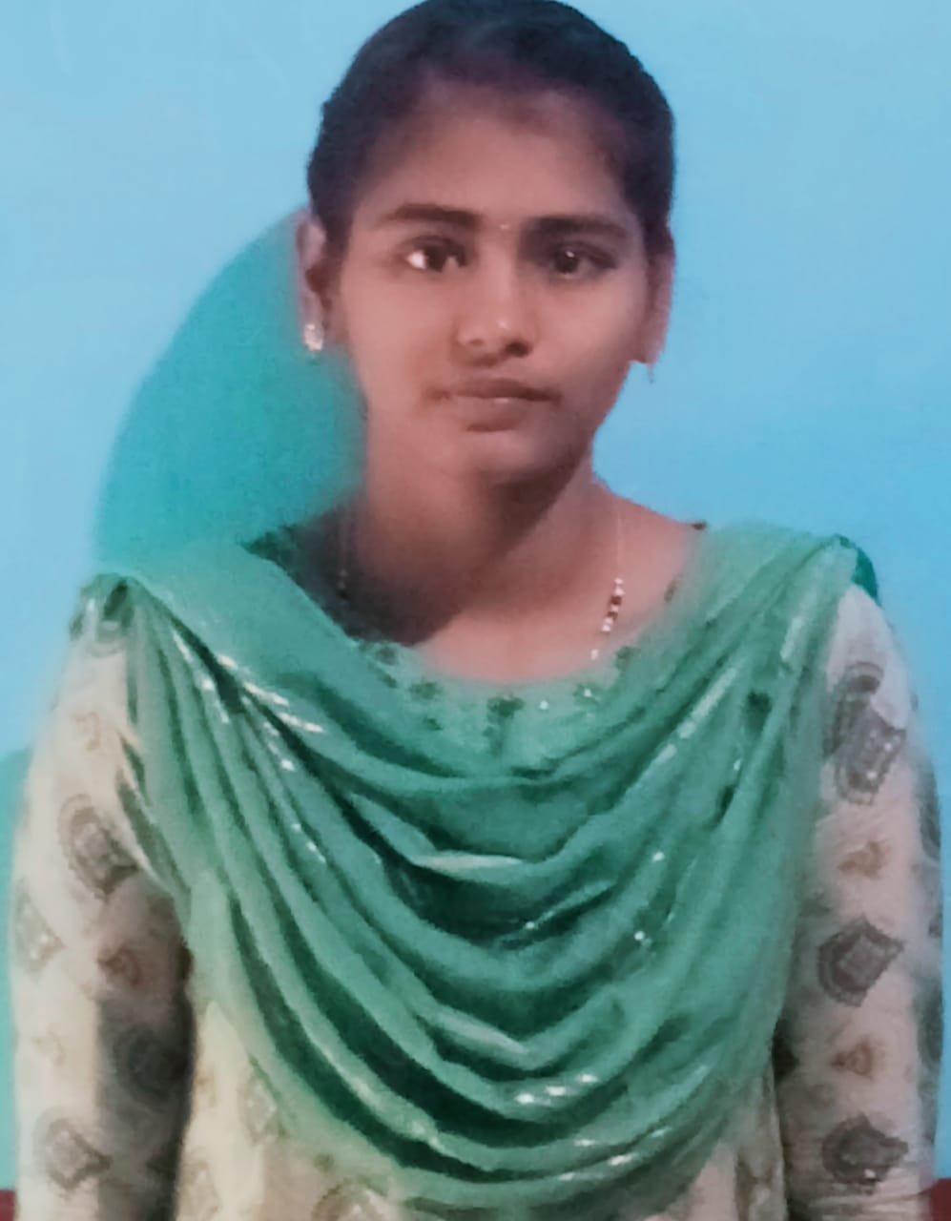

THANGAVENI K

ENTRY-LEVEL SOFTWARE ENGINEER